**Module 2: How is NIEM Governed?**

**Slide 1 – Welcome Slide**

Welcome to Module 2: How is NIEM Governed?

**Slide 2 – Module Overview**

Module Overview

In this module we will discuss NIEM’s governance structure. The topics that we will cover are:

* The NIEM Community
* Domain Governance
* NIEM Program Governance and
* Additional Resources

**Slide 3 – The NIEM Community**

The NIEM Community

NIEM is built by the community, for the community.

The NIEM community is comprised of:

* Members from federal, state, territorial, local, tribal, private, and international organizations.
* Communities of interest (COI) – A group of people who share a common concern, set of problems, or interest in a topic.  Within the context of NIEM, COIs come together based on a common need to exchange information in order to advance their missions.  COIs need to have a shared vocabulary for the information they exchange.
* Domains and communities of interest (COIs) that represent a large, diverse user base inclusive of various missions, geographies, and types of organizations.

The NIEM community’s shared commitment to interoperability drives the program forward.

* NIEM’s active community contributes to model content, provides technical guidance, and offers tools and assets to streamline the development of exchanges.
* Collaboration across different mission spaces and organizations is critical and provides areas that previously operated autonomously to work together successfully.
* Successful information-sharing and exchange are best achieved through the active participation and collaboration of the many organizations involved in serving our nation and world.

**Slide 4 – Domain Governance**

Domain Governance

NIEM domains are formally established communities with executive stewards to represent the stakeholders, governance, and data model content oriented around their respective mission needs such as immigration or transportation. Each domain is led by a domain steward that is responsible for the domain’s model content, governance, and maintenance. Domain stewards work collaboratively with volunteer subject matter experts that collectively represent any involved Communities of Interest (COIs). Each domain represents individuals and organizations that cut across all levels of government, industry, and the international community.

Domain responsibilities:

* Improve federal stewardship and use of the model by promoting partnerships with non-federal stakeholders and better integration of governing Information Technology (IT) policies, processes, tools, mission-side sponsorship, and shared guidance.
* Manage reusable, community-specific content in the model and participate in NIEM governance at large.
* Identify opportunities for communities to create new domains.
* Manage their portion of the NIEM data model through effective governance frameworks and work with other NIEM domains to collaboratively identify areas of overlapping interest.
* Collaborate with other domains to govern NIEM core, a namespace that includes elements such as Person Name and Vehicle common across most of the domains.

**Slide 5 – NIEM Program Governance**

NIEM Program Governance

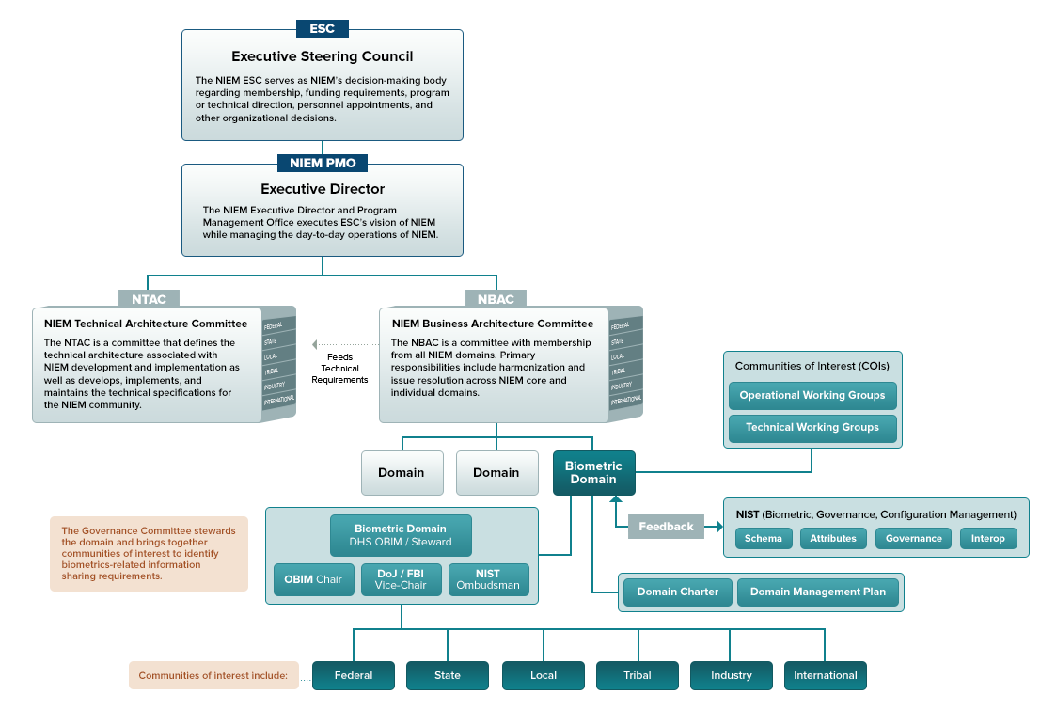

NIEM’s governing structure is comprised of:

* The NIEM Executive Steering Council (ESC): The ESC is NIEM’s decision-making body regarding membership, funding requirements, program or technical direction, personnel appointments, and other organizational decisions as required for supporting NIEM management.
* The NIEM Program Management Office (PMO): The PMO executes the vision of NIEM coordinated among the NIEM Business Architecture (NBAC), NIEM Technical Architecture (NTAC), PMO, and the ESC. The NIEM PMO encourages the adoption and use of NIEM and oversees working group and committee activities. The NIEM PMO coordinates with COIs, principal stakeholders, and other information-sharing initiatives to promote collaboration and interest in NIEM priorities.
* The NIEM Business Architecture Committee (NBAC): The NBAC guides the business requirements, harmonization or those requirements across mission needs, evolution, and implementation of NIEM Core and its domains. The NBAC also defines and governs the foundation and processes for establishing and supporting the participation of NIEM domains through a federated governance approach.
* And the NIEM Technical Architecture Committee (NTAC): The NTAC defines the technical architecture associated with NIEM development and implementation, and develops, implements, and maintains the technical specifications for the NIEM community.

**Slide 6 – Additional Resources**

For an overview of additional NIEM resources related to this module, please visit the following links:

* INSERT <https://www.niem.gov/communities/domain-governance> LINK
* INSERT <https://www.niem.gov/about-niem/niem-governance> LINK

Looking to get involved or start a new domain?

* INSERT <https://www.niem.gov/communities> LINK
* INSERT <https://www.niem.gov/communities/create-a-domain> LINK